Comparison of Smartphones Hardware Trends

**Abstract:**

Mobile device becomes very important part of our daily life. Upcoming technologies break the concept of limitation in terms of Architecture, memory and performance. This paper deals with the growth of mobile Architecture, mobile memory, mobile performance and additional features like accelerometers and compasses. As time passes mobile processors are growing rapidly. Communication, performance, and low-power operation are affecting the design and deployment of mobile processors over the years. To make a smartphone work like a computer manufacturers make phones with processor like ARM11, CortexA8, Snapdragon, Tegra and Armada etc. Choosing flash memories for mobile phones will immensely help manufacturers to achieve their goals i.e. “more flash memories with less cost”. Mobile RAM’s are optimized to reduce the battery usage and increase the performance of the smart phones. Mobile storage is an important factor for mobile developers because smart phones should have enough memory to handle installing, running the application and switching from one application to another. Identifying the problems and finding a solution to implement accelerometer and electronic compasses in smart phones without depending of Wi-Fi infrastructure is very complex. Noisy phone sensors and human movement makes it tough to deal with the implementation of the compass. This paper also describes the comparisons of mobile phones with respect to the operating system, Graphical processing unit, Control processing unit, Memory size, Storage and Battery life.

**1. INTRODUCTION:**

As mobile phones become more versatile, they are used for various purposes. Smartphone hardware consists of processors, Random Access Memory (RAM), Energy consumption and additional real-time features like accelerometers, etc. Processors that are made for mobile phones are restricted in terms of power, cost and real time computational requirements. New generation high performance processor chips can overcome those limitations. Performance related aspects are a major concern in today’s society due to the rapid growth of usage of Smartphones in day to day life. Memory size greatly increases in every upcoming release of new smartphones [5]. Size and weight of the mobile phone affects the battery size. Modern high end devices like smartphones are performing computer-like functionalities, which squeezes out the energy from the small size battery and deepens the need for effective energy management [1]. Therefore, this paper mainly concentrates on the comparisons of hardware components of smartphones evolving in the 21st century.

This paper is organized as follows: Section 2 describes the processor chip evolution in Smartphone history. Section 3 and Section 4 depict different processors and the memory evolution over the decade, respectively. Section 5 discusses additional features of Smartphones and finally, Section 6 summarizes all of the smartphone attributes.

**2. Smartphone Processor Architecture:**

There are many distinctions in mobile processors based on trends, technologies and performance.

**2.1 Digital signal Processor (DSP) Architectures**

There are two types of Digital signal Processor based on release and timeline. They are Traditional DSP Architectures and Modern DSP Architecture. Traditional DSP Architecture is designed as single standalone integrated circuits (IC’s). They can be programmed to be used in wireless handsets for digital cellular telephony. Modern DSP Architectures are evolved for Smartphones, to perform parallel processing and to have more computational power due to more chip fabrication [4].

**2.2 System on Chip (SOC) Architecture**

Smartphone device architecture becomes simpler by using System on Chip. DSP hybrid (DPA with SOC) architecture versions can handle the responsiveness in a device to improve performance. SOC architecture provides the flexibility of having high performance with low power design. To speed up the operations of Smartphones, many companies have implemented instruction set customizations. Most of the Smartphones today, use a single or dual core SOC’s [4].

**3. Smartphone Processors Types**

**3.1 ARM (Advanced RISC Machines) Processor**

Advanced RISC Machines processors are used in Smartphones because of less power consumption and better performance. It is basically a 32-bit instruction set on Reduced Instruction Set Computing(RISC) architecture. The first ARM architecture version is ARMv4 used for low-end Smartphones, followed by ARMv6, ARMv7, ARMv8. ARMv8 is the latest version, which contains a hardware floating point unit providing speed improvement [4]. A single core ARM cortex v8 was clocked with 1.4GHz which is reasonable in the year 2011, but in 2014 ARM processors were clocked with 3GHz. ARM processors with 64 bit perform twice as fast compared to 32 bit ARM processors [4].

**3.2 Qualcomm Snapdragon Processors**

Snapdragon comes under the family of SOC architecture provided by Qualcomm. It has the same features as ARM, but with an included feature utilizing Single Instruction, Multiple Data(SIMD). Qualcomm Snapdragon improves graphics performance of smartphone games. Qualcomm was the first to introduce a 28nm processor in 2012 [4]. In 2013, Qualcomm Snapdragon released the Snapdragon 800 processor which beats all the processors in the field of Smartphones. Snapdragon 800 opens apps and web browsers very fast and it has outstanding graphics, good battery life, ultra HD video and multiple HD audio [4].

**3.3 NVidias Tegra Processors**

Tegra is also a SOC architecture developed by NVidia. It includes an ARM processor, graphic processing unit and memory controllers. NVidia Tegra 4 processor is a quad core SOC with improved performance. NVidia is technically faster, but when power efficiency is compared Qualcomm snapdragon wins. Different processor performance can be compared using the software called [GeekBench3](http://www.primatelabs.com/geekbench/), which calculates the benchmark utilizing a baseline score of 2500 (which is the score of Intel Core i5) [4]. Score that is higher than the benchmark score implies better processor performance. Figures 1 shows Android operating system processors, benchmarks which reflect the best processors in 2015.

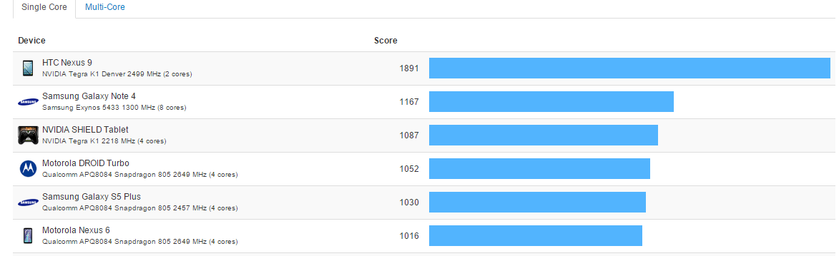Figure 1: Android Operating System (OS) processor benchmarks [7].

**4. Smartphone Memory:**

The enormous growth of smartphone users led to an increase in the demand for app developers which in turn increases the demand for memory space in smartphones. Smartphones are provided with two types of memory: Internal flash storage and an External SD card. Flash memory is of electronically Erasable Programmable Read-Only Memory (EEPROM). EEPROM erases data as a group of blocks so that it is suitable for applications where astronomically immense amounts of data require frequent update. Flash memory uses two distinct logical technologies NOR and NAND. NOR is known for providing high speed reading, writing and access. The main purpose of NOR flash is to store the mobile Operating System (OS). NAND flash reads and writes consecutively at high speed which handles a single block of data called pages. NAND flash reads quicker than it writes and transfers the whole page of data. Many reviews do not consider internal NAND storage speed as a key factor for specifications. To compare the NAND performance of most popular Smartphones, the AndroBench tool is used, which tests the sequential and random speed [5]. AndroBench test focuses on large amount of data storage. For example, to transfer a movie stored in a sequential block of memory. The faster the results are, the faster is the ability to write or read a file. Figure 2 shows the results.

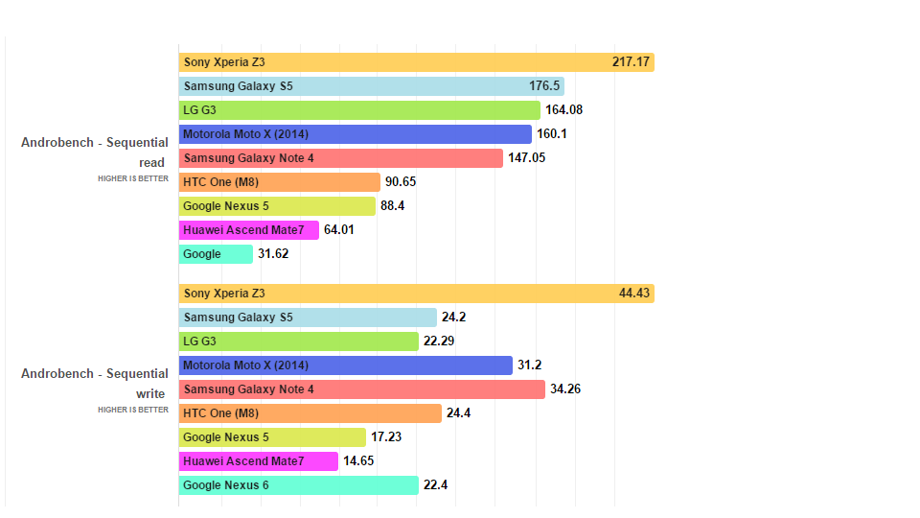Figure 2: Reading and writing speeds of different Smartphones [5].

Android and Apple iOS use the SQLite database to store the structured data as a primary means of storage. SQLite is a light weight database which occupies less memory space. Applications which have querying, retrieving and searching functions use one or more SQLite databases. Apple iOS core data is a data model which is built on top of SQLite providing access to applications, such as save, restore, undo and redo [3]. When the focus shifts to external storage, a large memory size always lead to a decrease in speed. Smartphones come with two different and standard memory cards called mini and micro-SD. They may vary in storage capacities from 16MB to 2TB. Table 1 lists SD cards’ performances on desktop and smartphones with respect to reading and writing speed.

Table 1: SD card cost and performance [3].

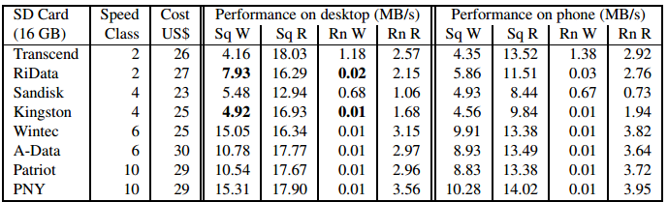

**5. Additional features of Smartphones:**

Implementation of additional feature, such as accelerometer or electronic compass, introduces challenges in predicting the walking speed and orientation of smartphone users. At first, the map is downloaded based on the user location to track the user. Using the assistance GPS reading, the phone calculates the location of a user frequently. Implementation of the accelerometer and electronic compass together form CompAcc. It is first implemented on Nokia N95 and works well for a small range [2].

**6. Conclusion:**

Different vendors are working for better smartphones which contain a powerful processor chip. Though all processors are ARM-based, they design with a different name by various cellular companies. Though enough progress is achieved in Smartphone development, to achieve an optimum level of satisfaction some factors like low power consumption, huge memory usage by applications, etc., have to be improved.

BIBLIOGRAPHY:

[1] Bi, M., Duan, R., Gniady C., Exploring memory energy optimizations in smartphones, Proceeding IGCC '11 Proceedings of the 2011 International Green Computing Conference and Workshops, IEEE Computer Society Washington, DC, USA , pages 1-8.

[2] Constandache, I., Choudhury, R. R., Rhee, I., CompAcc: Using Mobile Phone Compasses and Accelerometers for Localization, in IEEE INFOCOM, San Diego, CA, USA, march 2010.

[3] Kim, H., Agrawal, N., and Ungureanu, C. Revisiting storage for smartphones. In Proceedings of USENIX Conference on File and Storage Technologies (FAST) 2012, USENIX Association.

[4] Singh, M, P., Jain, M, K., Evolution of Processor Architecture in Mobile Phones, Proceedings International Journal of Computer Applications (0975 – 8887), Volume 90 – No 4, March 2014.

[5] Victor, H., Phone Arena, PhoneNews, Android storage speed comparison: which phone has the fastest IO performance, 04 Feb2015, <http://www.phonearena.com/news/Android-IO-speed-comparison-which-phone-has-the-fastest-internal-storage_id65588>.

[6]G.Geoffre.,GeekBenchBrowser,AndroidBenchmarks,[http://browser.Primatelabs.com/android -](http://browser.Primatelabs.com/android%20-)benchmarks.

[7] K, Russel., Computerworld, FlashMemory, 7Jun,2010, <http://www.computerworld.com/> article/ 2550624/data-center/flash-memory.html